Galerucella Beetle Life Cycle:
Background Information
Did you know that some insects hibernate? Galerucella beetles are an example.
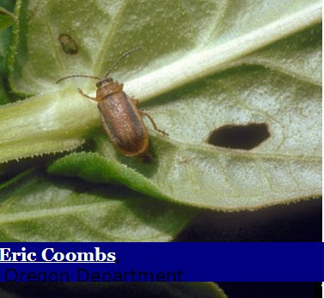
Like many other insects, the Galerucella Beetle completes a four stage life cycle. It spends the winter as an adult, hibernating, and becomes active in the spring, feeding and laying eggs. The eggs develop into larvae, then into pupas which transform into adult beetles.

Beetles spend a 2-3 weeks in each of the egg, larva, pupa stages and may lay many eggs when they are adults.
You can often find eggs on the stems of purple loosestrife, larva feeding on the plant bud tips and adults on the leaves. It is unlikely that you will ever see the pupa stage, as they are buried in the soil during this stage.

Gallerucella beetles need purple loosestrife to complete all four stages of their life cycle.
For images of the pupa stage and more information, go to http://www.extension.umn.edu/distribution/horticulture/DG7080.html
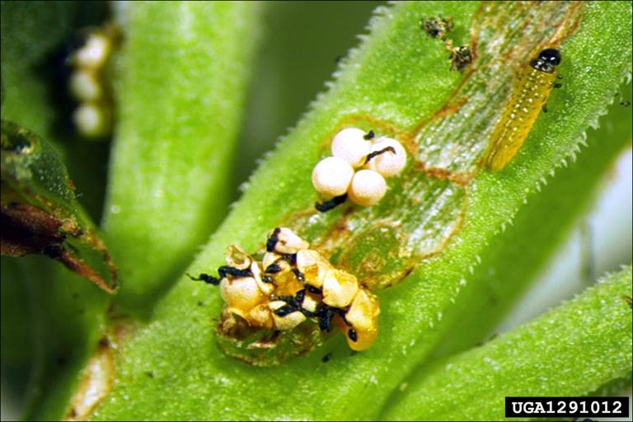
Bernd Blossey, Cornell University, United States
Eggs
Larva

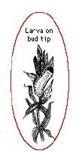
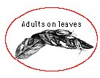
Life Cycle Worksheet
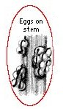
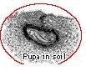

Cut out the images above. Put them in the correct order for the Galerucella life cycle. Draw arrows to show the cycle.

Draw a purple loosestrife plant below and draw arrows to show where the Galerucella beetle lives during its different life stages.

Life Cycle Worksheet
Answers

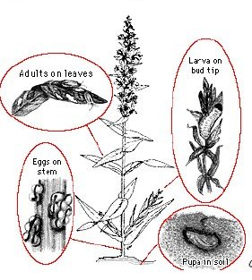

Images from Biological Control of Purple Loosestrife: A Guide for Rearing Leaf-feeding BeetlesAlyson Loos, Jr. Scientist David Ragsdale, Professor Entomology
Copyright © 2008 Regents of the University of Minnesota. All rights reserved.

